*Application Form*

*For Internship on the UmPhafa Private Nature Reserve*

Please complete this form if you wish to apply for an internship at the UmPhafa Private Nature Reserve.

The information you supply on this form will enable us to assess your application as fully as possible.

Please email your completed form to: [wendy@colchesterzoo.org](mailto:wendy@colchesterzoo.org)

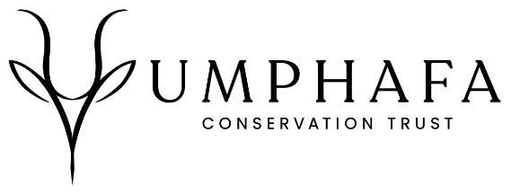

**Personal Details**

|  |  |  |  |
| --- | --- | --- | --- |
| Name: | Surname: | | D.O.B: |
| Sex: | | Nationality: | |

**Contact Details**

|  |  |
| --- | --- |
| Street name & number |  |
| Town/City |  |
| County |  |
| Post Code |  |
| Country |  |
| Telephone |  |
| Mobile |  |
| Email |  |

**Where did you hear about this placement?**

**Languages**

|  |  |
| --- | --- |
| Primary |  |
| Secondary |  |
| Others  (please list with level of competency) |  |
|  |
|  |

**Please state your reasons for wishing to take part in the projects of UmPhafa**

|  |  |  |
| --- | --- | --- |
| **Costs for two weeks** | | |
| 10th September – 24th September 2024 | **£800** |  |
| 24th September – 8th October 2024 |  |

*(This is not a firm commitment, and you may adjust this time after an offer of placement has been made)*

**PLEASE NOTE: A £100 surcharge for airport transfers will be applied if no other bookings are taken during your preferred deployment date**

If you are a UK tax payer, you can boost your donation by 25p for every £1 you donate.

* I am a UK taxpayer and understand that if I pay less Income Tax and/or Capital Gains Tax in the current tax year than the amount of Gift Aid claimed on all my donations it is my responsibility to pay any difference

**Are you willing to participate in the strenuous physical activity required by work placements on the reserve?**

**Do you have any special dietary requirements? (Please specify)**

**PLEASE ENSURE YOU INCLUDE A COPY OF YOUR CV WITH THIS APPLICATION FORM**